**Sprint 2**

|  |  |
| --- | --- |
| Team ID | PNT2022TMID07381 |
| Project Name | Personal Assistance for Seniors Who Are SelfReliant |

1. Create a Form using Node-red to get the Medicine Details :

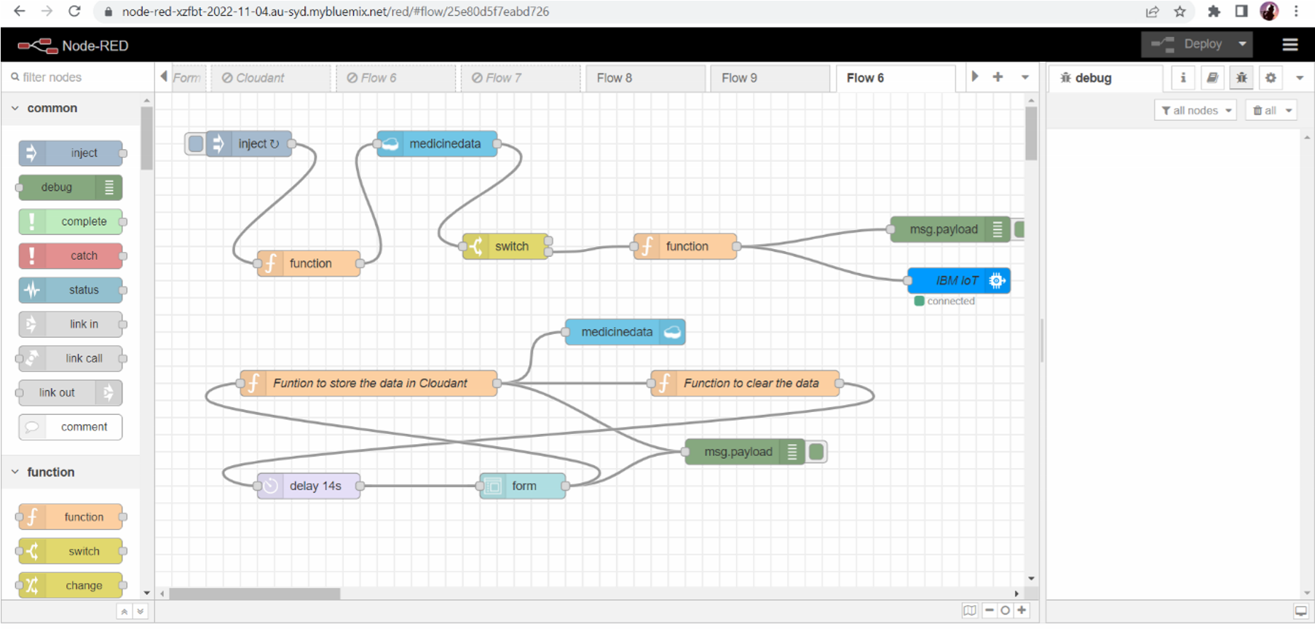

1. Adding IBM IoT Credentials to connect with virtual devices

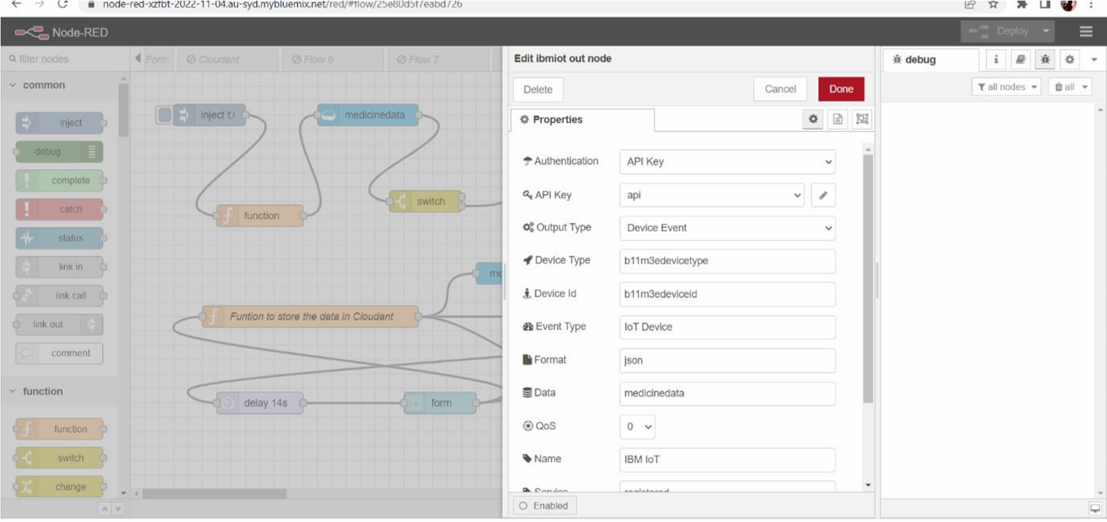

1. Function to Store the Medicine datas in Json format

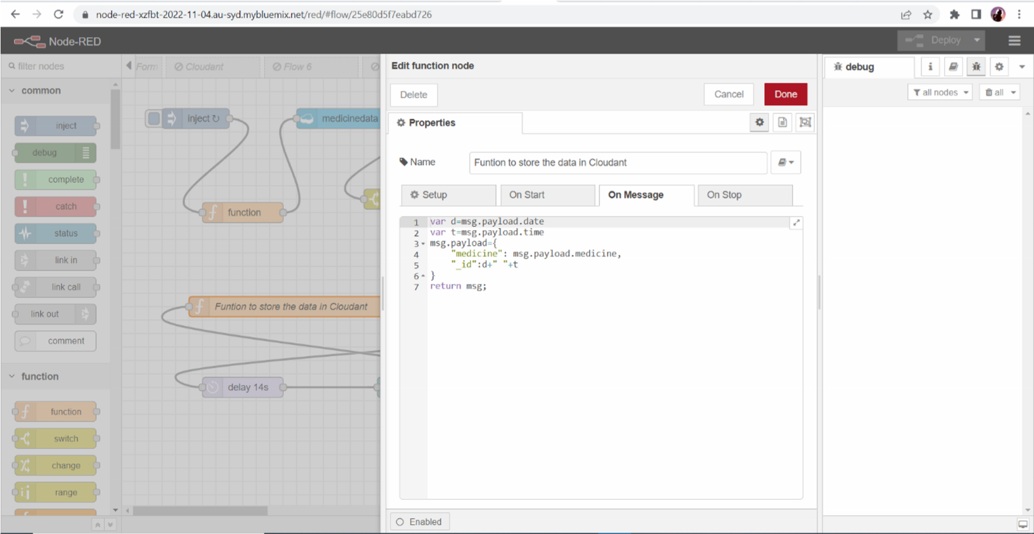

1. Compare the Present time with Stored time in cloudant

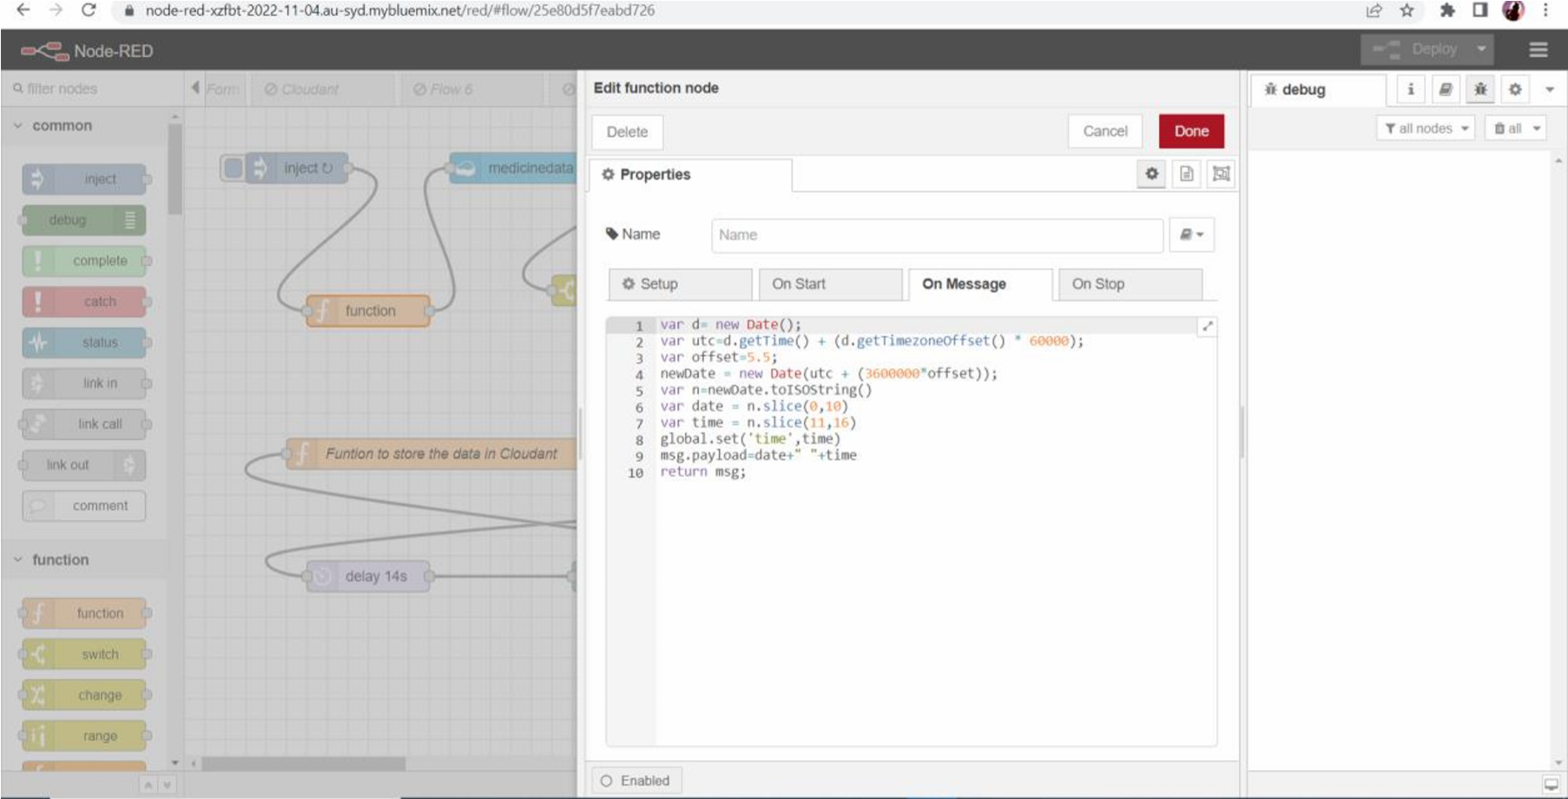

1. Form to Get the User Datas

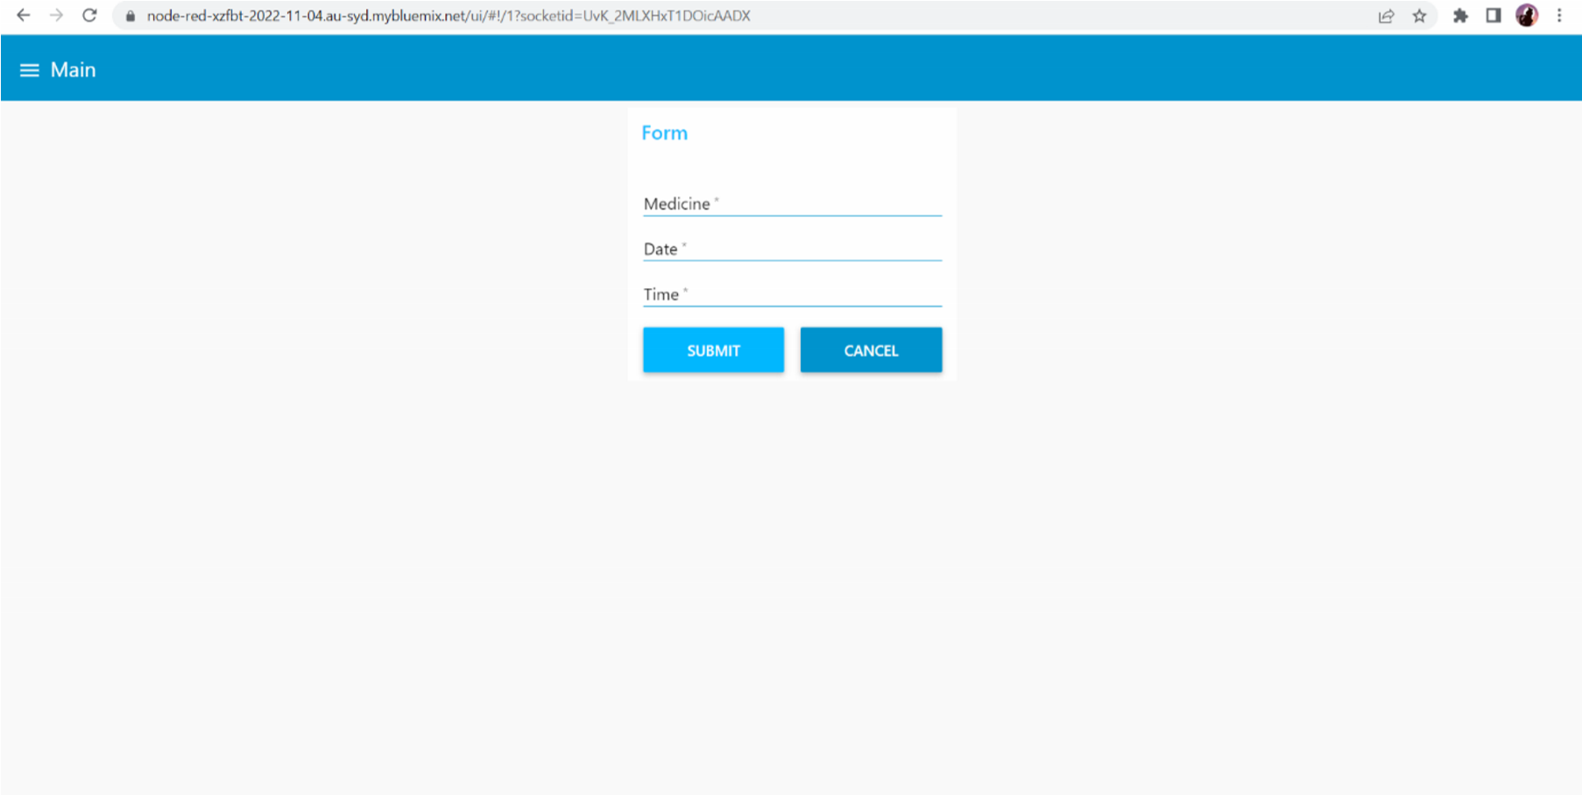

1. After getting the datas from form, store it in cloudant Database

